Cinematik IFF will open with the exclusive Slovak premiere of one of the most important films of the year: The Hungarian Dressmaker – a drama by Iveta Grófová from the World War II era based on the novel by Petr Krištúfek

Press release, 26 July 2024

The nineteenth edition of the Cinematik IFF will open this year with a new film by Iveta Grófová during the opening ceremony on Tuesday 10 September 2024. The Hungarian Dressmaker, a capturing drama from the time of the Aryanisation and the persecution of minorities during the wartime fascist Slovak state, is a film adaptation of Petr Krištúfek's 2014 novel of the same name. The film had its world premiere in June in the main competition of the Karlovy Vary IFF and will be presented to Slovak audiences at Cinematik in an exclusive home premiere with a large film delegation.

The nineteenth edition of the Cinematik IFF will open this year with a new film by Iveta Grófová with the opening ceremony on Tuesday, 10 September 2024. The Hungarian Dressmaker, a narrative drama from the time of the persecution of minorities during the wartime Slovak state, is a film adaptation of Petr Krištúfek’s 2014 novel Ema a smrtihlav. The film had its world premiere in June in the main competition of the Karlovy Vary IFF and will be presented to Slovak audiences at Cinematik in an exclusive home premiere with a large film delegation. The 19th Cinematik Film Festival will take place in Piešt’any from 10 to 15 September 2024. During the opening night, visitors will see the Slovak premiere of the film The Hungarian Dressmaker (2024) by Iveta Grófová. The author of Little Harbour (2017) and Made in Ash (2012) based her feature film on the novel by Petr Krištúfek, a writer, director and screenwriter who died in a tragic car accident in 2018.

Starring Alexandra Borbély (winner of the 2017 Best European Actress Award by the European Film Academy), Milan Ondrík, Nico Klimek, Éva Bandor, Táňa Pauhofová

and others, the film is set during World War II. It tells the story of a Hungarian widow, Marika, who, after losing her job in an Aryanised Bratislava tailor shop, hides a Jewish boy – the son of her former employer. It depicts the dramatic war era in the environment of the then Slovak-Hungarian border region in an atmosphere of escalating hostility towards minorities. The narrative film was almost seven years in the making, also due to forced breaks in filming during the lockdowns, and had its world premiere in the main competition of this year’s Karlovy Vary International Film Festival.

The Hungarian Dressmaker tells of the fragile boundaries between humanity and the protection of one’s own life where one excludes the other. In her own words, Iveta Grófová is particularly attracted to Petr Krištúfek’s novel by the stories of the main characters and the atmosphere, but she also draws attention to its broader social implications. Although the story takes place in the relatively distant past, the director points out that it is in some ways quite contemporary and timeless. “The parallels with today’s Slovakia, even in the context of the attempted assassination of the Slovak Prime Minister, are chilling. Once you start using hateful language, it starts a vortex that can take everyone down. Even those who started the whirlpool,” says the winner of the Crystal Bear at the Berlinale (Generation Kplus category) and two Slovak national film awards, the Sun in a Net. However, she says she doesn’t approach the characters in the story (many of whom were ordinary Slovak citizens) in black and white. She tried to build the plot on the fact that even its more controversial heroes faced their own dilemmas and often tried to do only what they thought was best.

The nineteenth edition of the Cinematik International Film Festival will bring, in addition to the premiere opening film, nearly a hundred other unique cinephile experiences. Great foreign and domestic feature films and documentaries await the audience in two competition sections and several non-competition ones. In addition, side events, lectures, a rich industry and music programme will also be part of the audience’s favourite six-day festival.

Events, lectures, rich industry and music programme. Accreditations for the 19th edition of the Cinematik International ﬁlm Festival are on sale at the festival's official website www.cinematik.sk.

Press release: Lucia Fajnerová & Peter Konečný
PR contact: Peter Konečný
+421 905 316 005
e-mail: peter.konecny@cinematik.sk
www.cinematik.sk

The event was financially supported by:
Co-organizers:

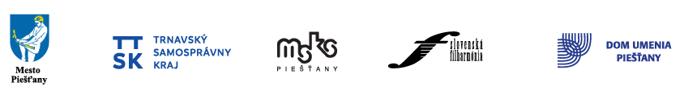

Advertising partners:


Exclusive media partner: Special Programme Partner:


Main media partners:
Media partners:

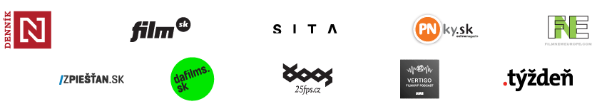

Film partners:
